# Criteria B: Design

By: Hrithik Shah

Date: October 26, 2015

## Detailed Design Specifications:

In this section, Criteria A’s specification were explored one by one in detail.

|  |  |
| --- | --- |
| **Criteria A** | **Criteria B** |
| text based storyline | * back-story * 5 min gameplay |
| interactive | * 4 tasks * user impacts end story * scoring/deaths/points * math functions |
| visually appealing | * ASCII art * ASCII titles * Spaces between question and answer * no horizontal scroll |
| adaptable | * usage of methods * comments |
| user-friendly | * teenage appropriate * error-free * ifs/else-ifs/elses |
| shows advanced usage of Java coding skills | * usage of methods * efficient * ifs/else-ifs/elses * loops |

## Feasible Design Ideas:

Theme

Major Themes that I would like to incorporate into the game:

These 4 themes were the ones that I found most intriguing. I brainstormed ideas on what I can pursue in my game.

Theme 1: James Bond/Mission Impossible

* Idea: The player can be the one that is asked “Your mission, should you choose to accept …” In a way, the player is the special agent.

Theme 2: Nuclear War

* Idea: At the end of the game, near the climax, the player must stop a nuclear war. He must figure out where the nuclear missile will get launched from and figure out where the missile will land, so that the player can figure out how to stop it.

Theme 3: Brain Games

* Idea: The 4 tasks should challenge the player and make him think. This is the basic reason why we our creating these games so that we can enhance the brain’s cerebral capacities.

I am planning to incorporate all of these themes into the game. This will make my game creative and interesting. Nuclear War will also include a futuristic aspect to the game, making it inevitable to not make a good back-story.

## Task Ideas:

In this section, I thought about some of the programs that we had done in class and decided if I should include it in my game.

## Accurate and Detailed Designs

Storyline

There is a war between the Western Nation and the Eastern Nation over fresh water reserves. The Eastern Nation is planning to launch nuclear missiles against the Western Nation causing a lot of distress. The player is to in act the role of a secret agent and try to stop the nuclear missiles from getting launched.

Structure Chart of Game

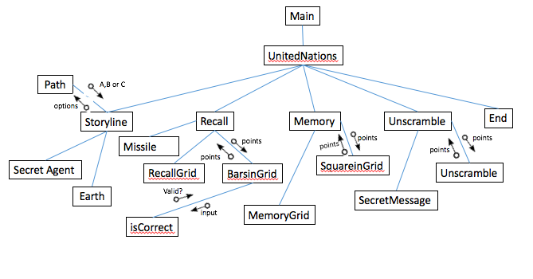

This structure chart shows the different methods that will be used in my game. These methods will consist of void methods and and some that return ints for points and some that take parameters for points. The void methods will print out the different ASCII art pictures.

**Task 1: Recall**

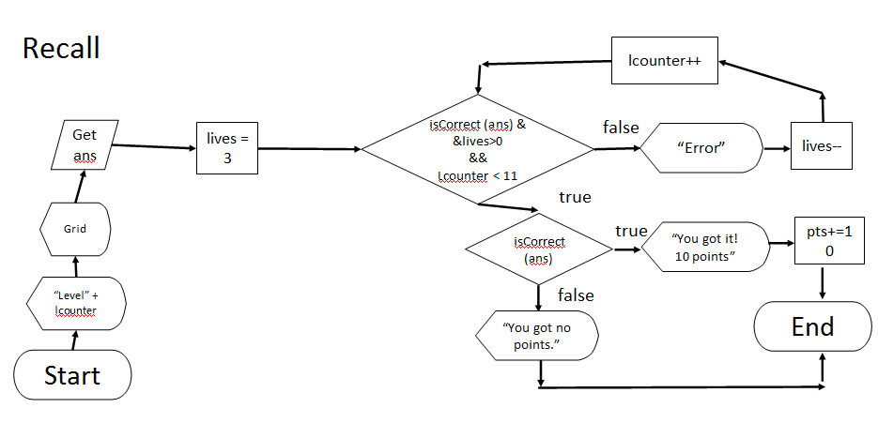

This will need a series of loops to make sure the number of lives get checked every level and make sure the answer is correct.

**Task 2: Unscramble**

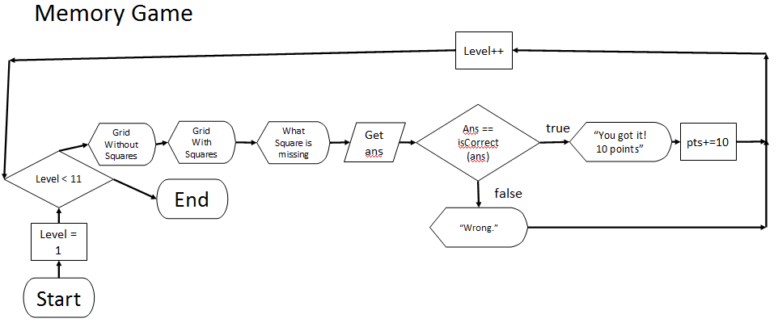

**Task 3: Memory Game**

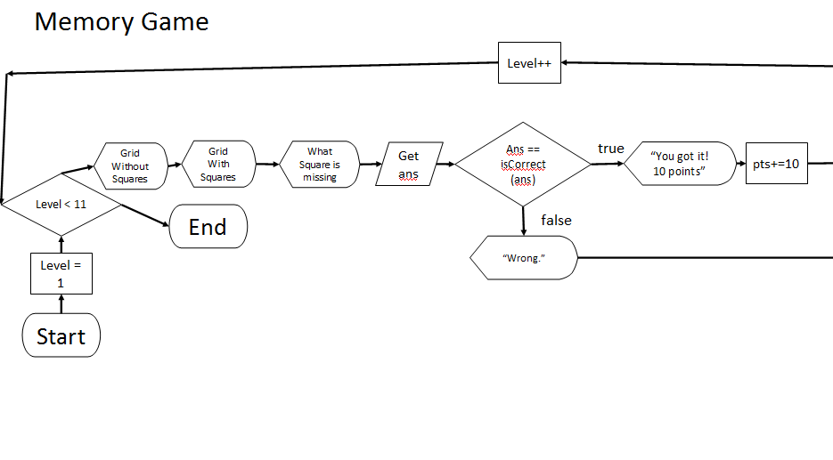

**ASCII Art**

This will help make the game visually appealing as well as cover one of the requirements for the game.

|  |
| --- |
| ()_  || `-._.-.  ||_ .'  || `-.'  + || +  | || |  / \ _,,.||.__ / \  /___\ ,-' `-. /___\  ______|===|_________,' `.__________|===|______  / |===| / \ |===| \  /___________________/ \____________________\  | +-----+ +-----+ |`-._ _.-'| +-----+ +-----+ |  | ||_|_|| ||_|_|| | |. `'----------'' .| | ||_|_|| ||_|_|| |  | ||_|_|| ||_|_|| | |: | || :| | :| | ||_|_|| ||_|_|| |  ---| %%---%%+ +%%%--+ | |:__| ||____:| |__:| | +-%%%-+ %%---%%% |---  |%%%%_%%%%_%%%%%____| |/ | || - :| | \| |___%%%%%_%%%%_%%%%%|  `| %| `|' |`.`-._ | |' `| |__.-'.'| %|' `| %|MJP  |`.`-._``---....---''_.-'.'|  `. `-._``---....---''_.-' .'  `. ``---....---'' .'  `. .'  `. .'  `. .'  (). .()  /\_/\_/\_/\_/\_/\_/\_/\_/\_/\_||: :||_/\_/\_/\_/\_/\_/\_/\_/\_/\_/\  ||=||=||=||=||=||=||=||=||=||=||: :||=||=||=||=||=||=||=||=||=||=||  """""""""""""""""""""""""""""""" """"""""""""""""""""""""""""""""  The White House |

|  |
| --- |
| ++  ~?????I                :$O          ????????$?$?O  ?  ???        $$$$$$$$$$$$$$$$$$$$$$$$$$8        ?+.8????????   ?    ?        $$:8$$$$$$$$$$$$$$$$$$$$$$ $7            ??????????????        ?? $$$$$$$$$$$$$$$$$$$$$$$$$O  .            ???????I????            $$$$$$$$$+$$$$$$$$$$$$$$$$$           ??????????             ??.   8$$$$$ $$$$$$$$$$$$$.$  :            ???????               ??$$$ $  $$$$$$$$$$$$$$$$$$            .??                  ???$$$$$$$.$$8$OO$$$$$$$$$$$8              ???   ?+          +???$$$$$$$$ $$$   $$$  $$?                 ?  ~ D         +???$$$$$$$$$       $     $   ~                   ?????+         Z$ $$$$$$$$$     O    $D  +8                  ??????+?            $$$$$$$            . 8$   $I                   ?????????          $$$$$$                O$    $$ +                   +???????~          $$$$$$O Z               ?$$ $    O     Western ??????            $$$$  $              $$$$$$$$     Nation ????Z             $$$Z                 $$$$$$$$                     ???                    Eastern       $$$    =                      ?                     Nation           ,                      ?  Different Nations |
| :::::::::::::::::D::::::::::::::::8DI:::::::::::::::::::::::::::::::::::::::  ::::::::::::::::IZ:::::::::::::::DD:::::::::::::::::::::::::::::::::::::::::  ::::::::::::::::8:::::::::::::::DN::::::::::::::::::::::::::::::::::::::::::  ::::::::::::::::D::::::::::::::ZD::::::::::::::::::$DDDDDDDDDDDDDD8?::::::::  ::::::::::::::::D:::::::::::::=D::::::::::::::+DDDDNZ::::::::::::~ODDDNDDD::  ::::::::::::::::D:::::::::::::DD:::::::::::~DDD:::::::::::::::::::::::::$DDD  ::::::::::::::::D::::::::::::8D::::::::::=D$::::::::::::::::::::::::::::::::  ::::::::::::::::Z$:::::::::::D?::::::$MMMMD=::::::::::::::::::::::::::::::::  :::::::::::::::::D:::::::::::D::~MMMMMMMMMMMMMMM::::::::::::::::::::::::::::  :::::::::::::::::D:::::::::::DNMMMMMMMMMMMMMMMMMMM::::::::::::::::::::::::::  :::::::::::::::::Z+:::::::::~MMMMMMMMM   MMMMMMMMMMM::::::::::::::::::::::::  ::::::::::::::::::D::::::::NMMMMMMMM.      M MMMMMMMMDDZ::::::::::::::::::::  Z:::::::::::::::::DZ::::::MMMMMMMMMM       M MMMMMMMMM::::DD$:::::::::::::::  DD:::::::::::::::::D~::::+MMMMMMMMMM       M MMMMMMMMMM::::::8D8::::::::::::  :8D:::::::::::::::::D::::MMMMMMMMMMM      ?+ MMMMMMMMMMM::::::::DD::::::::::  ::?D:::::::::::::::::D::8MMMMMMMMMMMO     M .7MMMMMMMMMM::::::::::DD?:::::::  ::::D=::::::::::::::::D+MMMMMMMMMMMM     MM   . MMMMMMMM::::::::::::DD~:::::  :::::7D:::::::::::::::::MMMMMMMMMM        MM   .MMMMMMMM~::::::::::::?DD::::  :::::::8D:::::::::::::::MMMMMMMM,              =MMMMMMMM:::::::::::::::DD8::  :::::::::D8:::::::::::::MMMMMMM?               MMMMMMMMMD:::::::::::::::DDD:  :::::::::::DD::::::::::::MMMMMMD               MMMMMMMMM:D:::::::::::::::ZDD  :::::::::::::OD8:::::::::NMMMMMM .              MMMMMMM:::D:::::::::::::::DD  ::::::::::::::::8D8:::::::MMMMMM$              .MMMMMMI:::8Z:::::::::::::::D  :::::::::::::::::::ZDDZ::::MMMMMM              .MMMMMO:::::D::::::::::::::::  ::::::::::::::::::::::::::+IMMMMMM               MMM+::::::ID:::::::::::::::  ::::::::::::::::::::::::::::::MMMM .             MD:::::::::D:::::::::::::::  ::::::::::::::::::::::::::::::::MM.          . .?8::::::::::8:::::::::::::::  :::::::::::::::::::::::::::::::::::: . .     :::=::::::::::::I::::::::::::::  ::::::::::::::::::::::::::::::::::::I:::::::::::N::::::::::::O::::::::::::::  ::::::::::::::::::::::::::::::::::+O::::::::::::~::::::::::::D::::::::::::::  ::::::::::::::::::::::::::::::::ID:::::::::::::D:::::::::::::D::::::::::::::  ::::::::::::::::::::::::::::::DD::::::::::::::D::::::::::::::O::::::::::::::  Starting Screen |

|  |
| --- |
| .  NMMMMMMMM+ +MMMMMMMMN...                            .ZMMMMMMMMMMMMMMMMMMMMMMM$.                            MMMMMMMMMMMMMMMMMMMMMMMMMMM.                         . +MNMMMMMMMMMMMMMMMMMMMMMMMMM=..                    ...  . MMMMMMMMMMMMMMMMMMMMMMMMMMMMN..   .  .                  .  .+DMMMMMMMMMMMMMMMMMMMMMMMMMMMMMMMMMMMD+...               ...8MNMMMMMMIMNMMMMMMMMMMMMMMMMMMMMMMMMM?MMMMMMMMZ ,..               .8MMMMMMMMMMD$MMMMMMMMMMMMMMMMMMMMMMMMMZNMMMMMMMMMN8            ..7MMMMMMMMMMMMMM,MMMMMMMMMMMMMMMMMMNMMMM,MMMMMMMMMMMMMMI .             .MMMMMMMMMMMMMMMMM+:DMMMMMMMMMMMMMMMN:=MMNMMMMMMMMMMMMMM               ZMMMMMMMMMMMMMMMMMMN?.. ,~=~,. .?MMMMMMMMMMMMMMMMMMM$               . MMMMMMMMMMMMMMMMMMMMMMMMMMMMMMMMMMMMMMMMMMMMMMMMM  .                  . +NMMMMMMMMMMMMMMMMMMMMMMMMMMMMMMMMMMMMMMMN+ .                  ...     ,ZNMMMMMMMMMMMMMMMMMMMMMMMMMD$, ..                  .  .. . .  .. .   .,::~~~::,..  ....    . .                            . +OMMMMMN.   ..,DMMMMM8?                            ZMMMMMMMMMMMMMMMMMMMMMMMMM$                            .DMMMMMMMMMM . MMMMMMMMMMD.                            .IMMMMMMMMMM...MMMMMMMMMM?                            . OMMMMMMM$ ..  $MMMMMMMZ.                            ..  . .... .  .  . . . . .,       .  ................. .            .   .             ................  . .     =MMMMMMMMMMMMMMMMMMMMM.            MMM.           .MMMMMMMMMMMMMMMMMMMMM~  .~MMMMMMMMMMMMMMMMMMMMMMMN~  .      . NMM           ~MMMMMMMMMMMMMMMMMMMMMMM  ?MMMMMMMMMMMMMMMMMMMMMMMMMM. .       .MMM..        ,MMMMMMMMMMMMMMMMMMMMMMMM  MMMMMMMMMMMMMMMMMMMMMMMMMMMM         .MMM.     . . MMMMMMMMMMMMMMMMMMMMMMMMM  MMMMMMMMMMMMMMMMMMMMMMMMMMMMM.        MMM..   .  .MMMMMMMMMMMMMMMMMMMMMMMMMM  MMMMMMMMMMMMMMMMMMMMMMMMMMMMMM. .   .~MMM~.   . .MMMMMMMMMMMMMMMMMMMMMMMMMMM  MMMMMMMMMMMMMMMMMMMMMMMMMMMMMM$.    .OMMMZ    . $MMMMMMMMMMMMMMMMMMMMMMMMMMM  MMMMMMMMMMMMMMMMMMMMMMMMMMMMMMMD..  .MMMMM .  .NMMMMMMMMMMMMMMMMMMMMMMMMMMMM  MMMMMMMMMMMMMMMMMMMMMMMMMMMMMMMMM . :MMMMM,   MMMMMMMMMMMMMMMMMMMMMMMMMMMMMM  MMMMMMMMMMMMMMMMMMMMMMMMMMMMMMMMM,. $MMMMM7. ,MMMMMMMMMMMMMMMMMMMMMMMMMMMMMM  MMMMMMMMMMMMMMMMMMMMMMMMMMMMMMMMMN+.MMMMMMM.+MMMMMMMMMMMMMMMMMMMMMMMMMMMMMMM  MMMMMMMMMMMMMMMMMMMMMMMMMMMMMMMMMMM$MMMMMMMZMMMMMMMMMMMMMMMMMMMMMMMMMMMMMMMM  MMMMMMMMMMMMMMMMMMMMMMMMMMMMMMMMMMMMMMMMMMMMMMMMMMMMMMMMMMMMMMMMMMMMMMMMMMMM  The Spy |